Booking more than one seats in single booking: how to store data in the database,
Automatic seat booking on the basis of seat range: Given X is the number of seats an user want to book, and YZ is the range of rows preferred, the system should try to book the seats in continuous order in same row, if not possible in any of the rows in the given range, it should try to maximize the number of seats in the row and minimize the span across the rows.
How the case of more than one users trying to book the same seat will be handled: DataStructure similar to ConcurrentHashMap with n number of blocks, can be used to represent available seats, so that N users can concurrently book the ticket.
Right from the outset, before beginning to design any service there are a few questions which pop up in our minds like:
- What are the primary use cases or the features of your product?
- How much traffic are you estimating for your service to run up against?
- What are the primary design goals?
- Which database SQL or NoSQL will serve your requirement best?
Before getting on with the design we will be quickly discussing the above questions below:
- What are the primary use cases or the features of your product?
For an online movie ticket booking service I am assuming the features below:
  - The portal could list down different cities where it’s affiliate theaters are running.
  - Once the user selects the city the portal should display the movies released in that particular city.
  - Once the user selects the movie the portal should display the theaters running that movie.
  - The User should be able to select the show at a particular theater & book his tickets in the portal using payment gateway.
  - The portal should send real-time notifications to the user about new movie releases & other stuff.
- How much traffic are you estimating for your service to run up against?
  - BookMyShow has 3 billion+ page views per month & sells 10 million+ tickets a month.
Well, that’s quite a good amount of traffic. Your application must be pretty fast to display all the details about the movies.
  - During a popular much-awaited movie release, the traffic would spike up. The seats fill up pretty fast in no time. The system should be scalable, highly available to cope up with the traffic surge.
- What are the primary design goals?
  - The system should be highly concurrent. There will be multiple booking requests for the same seat at any particular point in time.
  - The core thing of the portal is ticket bookings which mean financial transactions. Which means the system should be secure & the database ACID compliant. You just cannot afford to have a glitch in the ticket booking flow.
  - The user interface should have a responsive design to run on devices of various sizes like mobile, tablet, desktop etc.
  - Keep read only data in the cache. Avert DB hits as much as you can. Cache the hell out.
  - Implement a distributed message queue to provide push notifications to the user.
  - Take the state out of the individual server nodes to a common in-memory database. For an instance port out user sessions from individual tomcat server nodes to a memory common to all the server nodes. This approach makes horizontal scaling of your architecture easier.
- Which database SQL or NoSQL will serve your requirement best?
When you think of the database you have two choices Sql or NoSql. Let’s do a quick analysis of the primary requirements:
  - Transaction handling: This is what SQL does best. Remember the ACID rule. Majority of the NoSql dbs. do relax the ACID constraints for achieving horizontal scalability.
(Eventual consistency is a consistency model used in distributed computing to achieve high availability that informally guarantees that, if no new updates are made to a given data item, eventually all accesses to that item will return the last updated value.)
  - What do we need to store?
    - We have to store cities running the shows.
    - Newly released movie details.
    - Theatres running in respective cities & their details.
    - Shows running in the theatres. Show details like date & time.
    - User information.
    - User’s booking information.
The data clearly has relations. Cities are related to movies & theatres. Movies are related to theatres. Theatres are related to shows.
Sql clearly wins when you have to store relational data. NoSql stores are inefficient with maintaining relations.
  - Data size
The system is read heavy. Majority of the data is read only. There are less writes in the system. The db size won’t grow exponentially like as that of a social network.
We will scale well with MySQL.

Here is a basic DB schema for the app:
(PK: Primary Key, FK: Foreign Key)

Tables
CITY: city_id(PK), city_name
CITY_MOVIE_MAP: city_id(PK), movie_id(FK)
MOVIE: movie_id(PK), movie_name, movie_release_date, movie_description
The unique ID have been assigned to avoid confilt happening due to similar names. For example, we can have two movies of the same name screening.
SHOW: show_id(PK), movie_id(FK), theatre_id(FK), city_id(FK), show_date, show_timings
Make combination of (theatre_id, show_date and show_timings) unique because any two rows of this table can’t have same value for all these three.
https://stackoverflow.com/questions/15800250/add-unique-constraint-to-combination-of-two-columns
THEATRE: theatre_id(PK), city_id(FK), theatre_name, theatre_address
USER: user_id(PK), user_name, user_details, booking_id(FK)
BOOKING: booking_id(PK), user_id(FK), booking_timestamp, show_id(FK), seat_id(FK)
SEAT: seat_id(PK), show_id(FK), seat_number, seat_status(Booked/Available), booking_id(FK), theatre_id(FK)
Make combination of (show_id and seat_number) unique because any two rows of this table can’t have same value for these two attributes.
You can further tweak it as you progress with the app development.
Since we are using an ORM we will have the same Java classes as tables.

Application Flow:
STEP 1: User selects the city.
The User is prompted to select the city on the home page of the portal. User selects the city.
Many movies can be released in a city so the CITY table has a one to many relationship with the MOVIE table.
After the user selects the city, the portal runs a query on the MOVIE table “select all movies where the city is x” & lists out all the movie rows corresponding to that city id.
STEP 2: User selects the movie.
Many theaters of the city can run the same movie.
The portal runs a query on the SHOW table “select all records where movie is x & city is y” to find the shows of a particular movie in the city. We show this information with theatre details also on the UI.
Step 3: User selects the show.
The portal runs a query on the SEAT table “select all seats where show_id is x”. The result lists out all the seats with the availability status.
Step 4: User selects the seats & clicks on the book seats button
A booking object is created with all the details & the system runs a db query adding a new row in the BOOKING table & updating the SEAT table.

Technology Stack:
UI: ReactJS & BootStrapJS
Server: Java, Spring Boot, Swagger, Hibernate (Scala, Play)
Security: Spring Security (Play Security)
Database: MySQL
Server: Tomcat (Netty)
Caching: In memory cache Hazelcast. (Redis)
Notifications: RabbitMQ. A Distributed message queue for push notifications.
Payment API: Popular ones are Paypal, Stripe, Square
Deployment: Docker & Ansible (Play project dist)
Code repository: Git
Logging: Log4J
Load balancer: Nginx

Architecture Diagram:
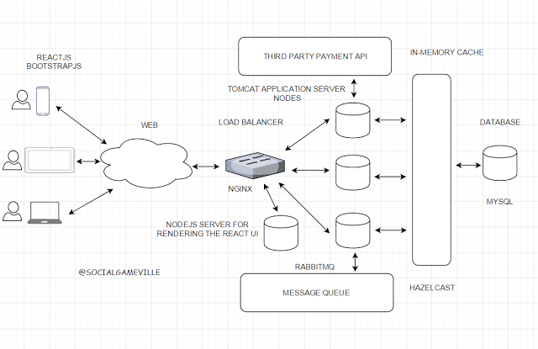

Well this pretty much covers the basic design of the portal. You can go in detail as much as you want. Designing a highly scalable system is a complex task & take years to perfect.
The architecture of a portal is being optimized & tweaked continually to cope up with high traffic influx. The system needs to be scalable, highly available, fast & fault tolerant.
When your business explodes you have to further separate out different flows of your monolithic app into respective Microservices for ease of maintenance & scalability.

